A Project Report On

Resume Scanning System

Submitted in partial fulfillment of the requirement for the award of the degree

Master of Computer Applications
(MCA)

Academic Year 2026 – 27

Dishen Gajera (92500584033)
Raj Vadaviya (92500584046)
Parth Ghelani (92500584053)

Internal Guide
Dr.Ashwin Dobariya



Rajkot-Morbi Road, At &PO :Gauridad, Rajkot 360 003. Gujarat. India.


Faculty of Computer Applications (FoCA)



This is to certify that the project work entitled

Resume Scanning System

submitted in partial fulfillment of the requirement for

the award of the degree of
Master of Computer Applications (MCA)

of the

Marwadi University

is a result of the bonafide work carried out by

Dishen Gajera (92500584033)

Raj Vadaviya (92500584046)

Parth Ghelani (92500584053)

during the academic year 2026-27

Faculty Guide |  | HOD |  | Dean

DECLARATION

We hereby declare that this project work entitled Resume scanning System is a record done by us.

We also declare that the matter embodied in this project is genuine work done by us and has not been submitted whether to this University or to any other University / Institute for the fulfillment of the requirement of any course of study.

Place : Marwadi University
Date :

Dishen Gajera (92500584033) Signature:___________
Raj Vadaviya (92500584046) Signature:___________
Parth Ghelani (92500584053) Signature:___________

ACKNOWLEDGEMENT

It is indeed a great pleasure to express our thanks and gratitude to all those who helped us. No serious and lasting achievement or success one can ever achieve without the help of friendly guidance and co-operation of so many people involved in the work.

We are very thankful to our guide Dr.Ashwin Dobariya, the person who makes us to follow the right steps during our project work. We express our deep sense of gratitude to for his /her guidance, suggestions and expertise at every stage. A part from that his/her valuable and expertise suggestion during documentation of our report indeed help us a lot.

Thanks to our friend and colleague who have been a source of inspiration and motivation that helped to us during our project work.

We are heartily thankful to the Dean of our department Dr. Rijwan Khan sir and HoD Dr. Sunil Bajeja sir for giving us an opportunity to work over this project and for their end-less and great support to all other people who directly or indirectly supported and help us to fulfil our task.

Dishen Gajera (92500584033) Signature:___________
Raj Vadaviya (92500584046) Signature:___________
Parth Ghelani (92500584053) Signature:___________

CONTENTS

Chapters | Particulars | Page No.
1 | Introduction to Project Definition
2  2.1 | PREAMBLE  Module description
3 | REVIEW OF LITERATURE  Analyze, Study and Compare the similar types of the systems/applications and highlights major findings
4  4.1  4.2 | TECHNICAL DESCRIPTION  Hardware Requirement  Software Requirement
5  5.1  5.2  5.3  5.4  5.5  5.6  5.7  5.8  5.9  5.10  5.11  5.12  5.13  5.14 | SYSTEM DESIGN AND DEVELOPMENT  (Only applicable diagrams)  - Algorithm  - Flow Chart  - Data Flow Diagram  - Class Diagram  - Use Case Diagram  - Sequential Diagram  - Activity Diagram  - State Diagram  - Database Design / File Structure (If applicable)  - Relationship Diagram (ER)  - Menu Design  - Screen Design  - Code of the module
6 | SYSTEM TESTING
7 | CONCLUSION
8  8.1 | LEARNING DURING PROJECT WORK  Future Enhancement
9  9.1  9.2 | BIBLIOGRAPHY  Online References  Offline References

FIGURE INDEX

Sr. No. | Figure No. | Particulars | Page No.
1 | Figure 5.1 | System Flowchart
2 | Figure 5.2 | Data Flow Diagram (Level 0)
3 | Figure 5.3 | Data Flow Diagram (Level 1)
4 | Figure 5.4 | Class Diagram
5 | Figure 5.5 | Use Case Diagram
6 | Figure 5.6 | Sequence Diagram
7 | Figure 5.7 | Activity Diagram
8 | Figure 5.8 | State Diagram
9 | Figure 5.9 | Entity Relationship Diagram
10 | Figure 5.10 | System Architecture Diagram

TABLE INDEX

Sr. No. | Table No. | Particulars | Page No.
1 | Table 4.1 | Hardware Requirement
2 | Table 4.2 | Software Requirement
3 | Table 5.1 | User Collection Structure
4 | Table 5.2 | Scan Collection Structure
5 | Table 6.1 | Functional Test Cases
6 | Table 6.2 | Performance Testing
7 | Table 6.3 | Security Testing

- Introduction to Project Definition

The Resume Scanning System is a web-based application developed using the MERN Stack (MongoDB, Express.js, React.js, and Node.js) that automates resume analysis and Applicant Tracking System (ATS) evaluation. The primary objective of the system is to help job seekers determine whether their resumes meet modern recruitment standards before applying for jobs.
Traditional resume screening is a manual and time-consuming process. Recruiters often receive hundreds of resumes for a single job opening, making it difficult to evaluate every application efficiently. Many organizations therefore rely on Applicant Tracking Systems (ATS) to automatically scan resumes, identify relevant skills, and shortlist suitable candidates based on predefined criteria.

The Resume Scanning System replicates this process by allowing users to upload resumes in PDF or DOCX format and compare them with a given Job Description (JD). The application extracts resume content, analyzes technical and soft skills, identifies missing keywords, calculates an ATS compatibility score, and provides suggestions for improving the resume.
The system also maintains user profiles, stores uploaded resumes securely in MongoDB, tracks previous scans, and provides detailed analytical reports that help users improve their chances of being shortlisted.

The project demonstrates the practical implementation of modern web technologies, RESTful APIs, cloud-based storage, document parsing, authentication, and database management in a real-world recruitment application.

2. PREAMBLE

2.1 Module description

The Resume Scanning System consists of the following major modules:

User Authentication Module
This module manages user registration, login, authentication, password encryption using JWT, and secure session management.

Resume Upload Module
Allows users to upload resumes in PDF or DOCX format. Uploaded resumes are validated and securely stored for further analysis.

Resume Parsing Module
Extracts textual content from uploaded resumes using document parsing libraries and converts it into structured information for analysis.

Job Description Module
Allows users to enter or upload a Job Description (JD) that serves as the benchmark for resume evaluation.

ATS Scoring Module
Compares resume content with the Job Description and calculates an ATS score based on keyword matching, skills, education, experience, formatting, and resume completeness.

Skill Analysis Module
Identifies existing technical skills, soft skills, certifications, programming languages, frameworks, and tools while detecting missing skills required for the target job.

Resume Recommendation Module
Provides personalized recommendations for improving resume quality, increasing ATS compatibility, and enhancing job application success.

Dashboard Module
Displays scan history, ATS scores, uploaded resumes, previous analyses, and personalized recommendations in a user-friendly interface.

Admin Module
Allows administrators to manage users, monitor uploaded resumes, maintain system records, and oversee platform activities.

3. REVIEW OF LITERATURE

Analyze, Study and Compare the Similar Types of Systems/Applications and Highlight Major Findings
- During the research phase, several existing systems and application paradigms were analyzed to shape the architecture of the Laughter Challenge:

3.1 Jobscan

Analysis
Jobscan is one of the most popular ATS optimization platforms used by job seekers worldwide. It compares an uploaded resume with a Job Description (JD) and calculates an ATS compatibility score. The platform analyzes keywords, skills, education, work experience, formatting, and resume readability.
Jobscan also highlights missing keywords that should be included to increase the chances of passing Applicant Tracking Systems.

Major Findings
- Accurate keyword matching improves ATS performance.
- Resume should closely match the Job Description.
- ATS score provides users with measurable feedback.
- Missing skills and keywords can significantly reduce interview opportunities.
- Personalized suggestions improve resume quality.

3.2 Resume Worded

Analysis
Resume Worded is an AI-powered resume review platform that evaluates resumes based on recruiter expectations. Instead of focusing only on keyword matching, it also evaluates writing quality, action verbs, professional summaries, achievements, and resume structure.
It provides detailed recommendations to improve both ATS compatibility and recruiter readability.

Major Findings
- Resume quality depends on both ATS optimization and human readability.
- Strong action verbs improve resume impact.
- Professional summaries should be concise and relevant.
- Achievement-oriented content performs better than responsibility-based descriptions.
- AI-generated recommendations help users continuously improve their resumes.

3.3 Zety Resume Checker

Analysis
Zety offers resume building and resume evaluation services. It checks document formatting, grammar, resume sections, professional appearance, and ATS friendliness. The platform emphasizes creating visually organized resumes while maintaining ATS compatibility.

Major Findings
- Proper formatting significantly affects ATS parsing.
- Standard section headings improve resume recognition.
- Consistent fonts, spacing, and alignment enhance readability.
- Well-structured resumes receive better recruiter attention.
- Clean layouts increase resume acceptance by ATS software.

3.4 Enhancv ATS Resume Checker

Analysis
Enhancv provides ATS analysis by comparing resumes against industry standards. It evaluates formatting, keyword optimization, skills, experience, and resume completeness while providing recommendations for improvements.
The system also checks whether resumes contain unnecessary graphics, tables, or formatting elements that may reduce ATS compatibility.

Major Findings
- Simple layouts are more ATS-friendly.
- Resume sections should follow a standardized order.
- Important keywords should naturally appear throughout the resume.
- Graphics and excessive styling may negatively affect ATS parsing.
- Resume completeness improves ATS scoring.

3.5 Kickresume

Analysis
Kickresume combines resume building, AI writing assistance, and ATS evaluation into a single platform. It helps users create professional resumes while offering automated suggestions for improving content quality and keyword optimization.
The platform also provides resume templates that balance professional appearance with ATS compatibility.

Major Findings
- AI-generated recommendations improve resume quality.
- Resume templates save preparation time.
- Standardized layouts improve parsing accuracy.
- Skill-based resume optimization increases recruiter visibility.
- Automated evaluation helps users identify weaknesses before job applications.

Comparative Study of Existing Systems
Feature | Jobscan | Resume Worded | Zety | Enhancv | Kickresume | Proposed Resume  Scanning System
Resume Upload | ✔ | ✔ | ✔ | ✔ | ✔ | ✔
ATS Score | ✔ | ✔ | Partial | ✔ | ✔ | ✔
Keyword Matching | ✔ | ✔ | ✔ | ✔ | ✔ | ✔
Resume Parsing | ✔ | ✔ | ✔ | ✔ | ✔ | ✔
Skill Analysis | ✔ | ✔ | Partial | ✔ | ✔ | ✔
Job Description Comparison | ✔ | Partial | ✖ | ✔ | Partial | ✔
Resume Suggestions | ✔ | ✔ | ✔ | ✔ | ✔ | ✔
Scan History | ✖ | ✖ | ✖ | ✖ | Partial | ✔
User Authentication | ✔ | ✔ | ✔ | ✔ | ✔ | ✔
Admin Panel | ✖ | ✖ | ✖ | ✖ | ✖ | ✔

Major Findings from Literature Review
After studying the existing systems, the following observations were made:
- Most ATS systems rely heavily on keyword matching between resumes and job descriptions.
- Resume formatting plays a crucial role in successful ATS parsing.
- Professional summaries and quantified achievements improve recruiter impressions.
- Many existing platforms require paid subscriptions to access advanced ATS analysis.
- Most available systems do not provide complete scan history and resume management in a single platform.
- AI-driven suggestions significantly improve resume quality and ATS compatibility.
- Secure user authentication and cloud-based storage enhance usability and scalability.
- Combining resume parsing, ATS scoring, keyword analysis, and scan history into one application provides a better user experience.

4. TECHNICAL DESCRIPTION

The Resume Scanning System is a web-based application developed using the MERN Stack (MongoDB, Express.js, React.js, and Node.js). It automates resume screening by comparing uploaded resumes with job descriptions, calculating an ATS compatibility score, and providing improvement recommendations. The system uses secure JWT authentication, REST APIs, and MongoDB to ensure efficient, scalable, and secure resume analysis.

4.1 Hardware Requirement

- Processor: Minimum Dual-Core Processor (Intel Core i3 / AMD Ryzen 3 or equivalent)
- RAM: 4 GB or higher
- Storage: Minimum 500 MB free disk space
- Display: 1366 × 768 resolution or higher
- Internet: Stable Broadband Connection
- Device: Desktop or Laptop with a modern web browser (Chrome, Firefox, or Edge)

4.2 Software Requirement

- Operating System: Windows, Linux, or macOS
- Programming Language: JavaScript, HTML5, CSS3
- Frameworks: React.js (Frontend), Node.js & Express.js (Backend)
- Database: MongoDB Atlas / MongoDB Community Server
- Styling Framework: Tailwind CSS
- Authentication: JSON Web Token (JWT)
- Tools & Libraries: Mongoose, Multer, pdf-parse, Mammoth, Axios, React Router
- Development Tools: Visual Studio Code, Postman, Git & GitHub
- Deployment: Vercel (Frontend), Render (Backend), MongoDB Atlas

5. SYSTEM DESIGN AND DEVELOPMENT

The Resume Scanning System is designed using the MERN Stack architecture to automate the process of resume screening and ATS score calculation. The system consists of multiple interconnected modules including user authentication, resume upload, resume parsing, keyword extraction, ATS score generation, recommendation engine, dashboard management, and database storage.
This chapter describes the complete system design using algorithms, flowcharts, data flow diagrams, UML diagrams, database design, Entity Relationship diagrams, menu design, screen design, and the implementation of important application modules.

5.1 Algorithm

Algorithm : Resume Scanning System
Step 1 : Start the Resume Scanning System.
Step 2 : Display the Login or Registration page.
Step 3 : Authenticate the user using Email ID and Password.
Step 4 : If authentication fails, display an appropriate error message and return to the
Login page.
Step 5 : If authentication is successful, redirect the user to the Dashboard.
Step 6 : Upload the Resume file in PDF or DOCX format.
Step 7 : Validate the uploaded resume format.
Step 8 : If the uploaded file format is invalid, display an error message and stop further
processing.
Step 9 : Extract textual information from the uploaded resume using the Resume Parser.
Step 10 : Allow the user to enter or upload the Job Description.
Step 11 : Extract important keywords from the Job Description.
Step 12 : Compare resume content with the Job Description.
Step 13 : Analyze technical skills, soft skills, education, projects, certifications, and work
experience.
Step 14 : Calculate the ATS Compatibility Score.
Step 15 : Generate improvement suggestions for missing keywords and resume quality.
Step 16 : Store resume details, ATS score, scan report, and scan history in MongoDB.
Step 17 : Display ATS Score, Matching Percentage, Missing Skills, and
Recommendations.
Step 18 : Allow the user to perform another scan or logout.
Step 19 : End the application.

5.2 Flow Chart
The flow chart illustrates the complete working procedure of the Resume Scanning System from user authentication to ATS score generation. It shows the sequence of operations performed by the system including resume upload, document parsing, keyword extraction, ATS analysis, recommendation generation, report storage, and result display.

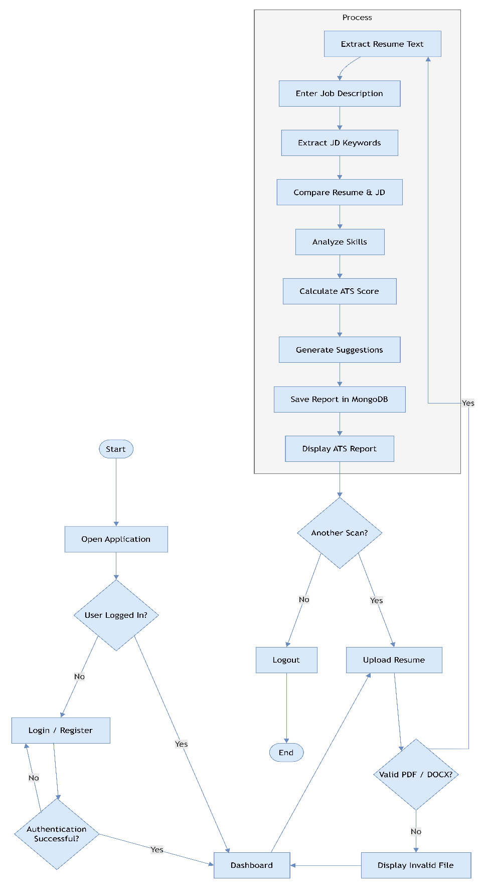

Figure 5.1 represents the Flow Chart of the Resume Scanning System.

5.3 Data Flow Diagram (DFD)

A Data Flow Diagram (DFD) represents the movement of data through the Resume Scanning System. It illustrates how information enters the system, how it is processed, stored, and finally presented to the user. The DFD provides a clear understanding of the interaction between users, processes, and the database.

5.3.1 DFD Level 0
In Level 0 DFD, the user interacts with the Resume Scanning System by registering, logging in, uploading resumes, and entering job descriptions. The system performs resume analysis, generates ATS reports, stores information in MongoDB, and returns the final analysis to the user.
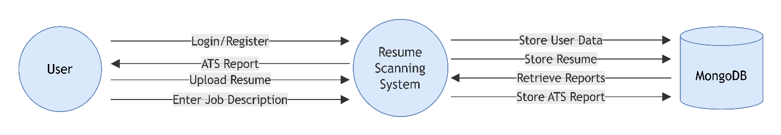

Figure 5.2 shows the Level 0 Data Flow Diagram of the proposed system.

5.3.2 DFD Level 1
The Level 1 DFD divides the system into several functional modules. Authentication verifies user credentials. Resume Upload accepts PDF or DOCX files. Resume Parser extracts textual content from the resume. Keyword Matching compares the resume against the Job Description. The ATS Score Generator calculates compatibility scores, while the Recommendation Engine suggests improvements. Finally, all reports are stored in MongoDB and displayed through the Dashboard.
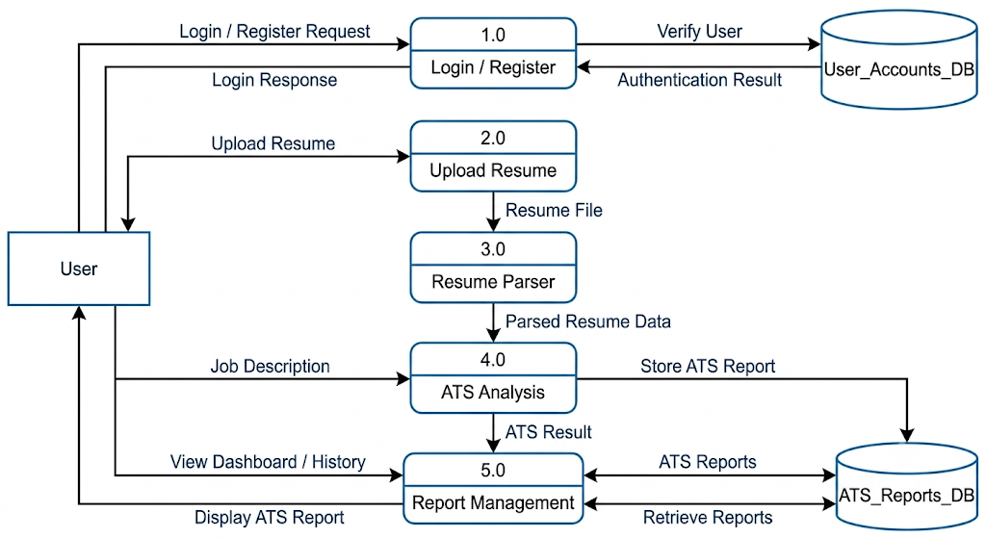

Figure 5.3 illustrates the Data Folw Diagram Leval 1.

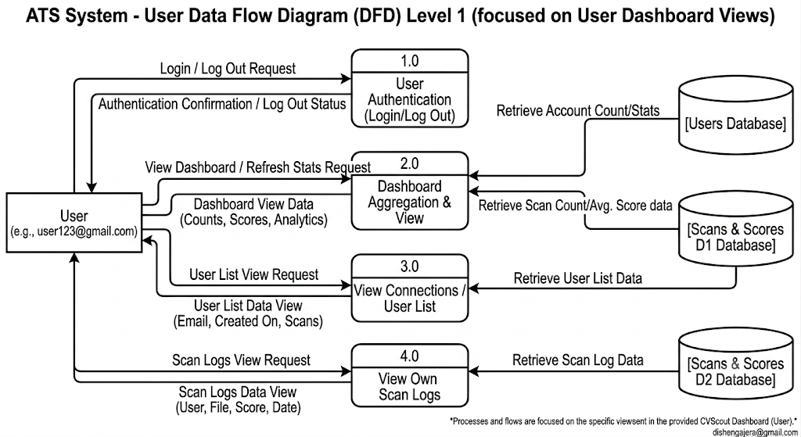

Figure 5.3 illustrates the Admin Data Folw Diagram Leval 1.

Level 2

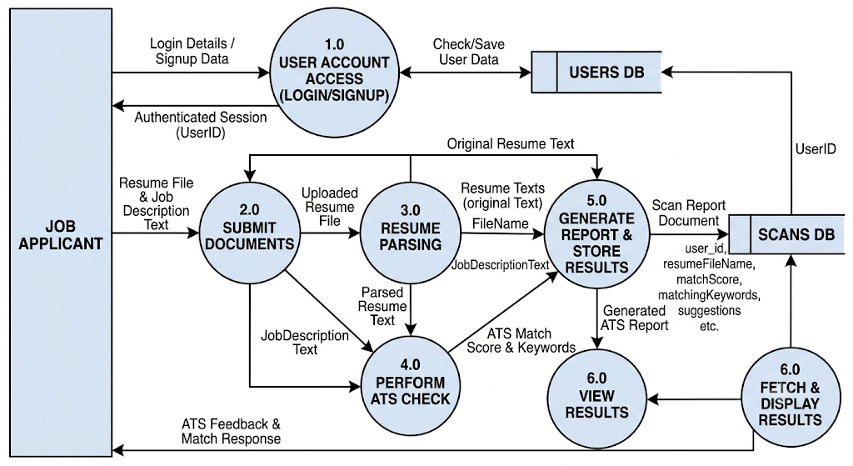

Figure 5.3 illustrates the Data Folw Diagram Leval 2.



Figure 5.3 illustrates the Admin Data Folw Diagram Leval 2.

5.4 Class Diagram

The User uploads resumes into the system. Each uploaded Resume is compared with a Job Description to generate an ATS Report containing the compatibility score and personalized recommendations.
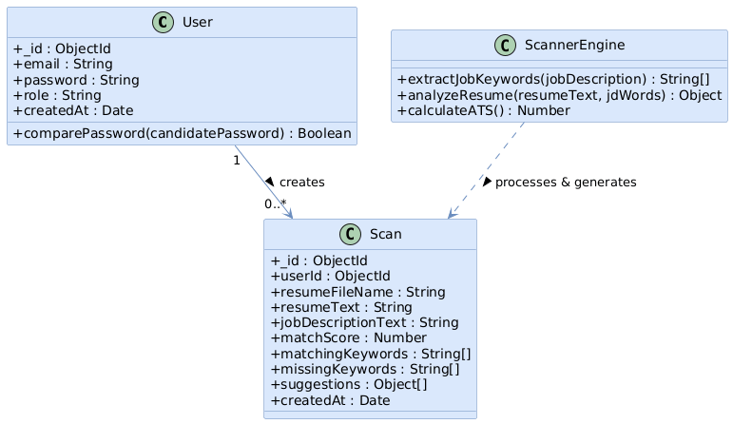
Figure 5.4 illustrates the Class Diagram.

5.5 Use Case Diagram

The user registers and logs into the system before uploading resumes and entering job descriptions. After scanning, the system generates ATS scores and improvement suggestions. Administrators manage user accounts and monitor system reports.
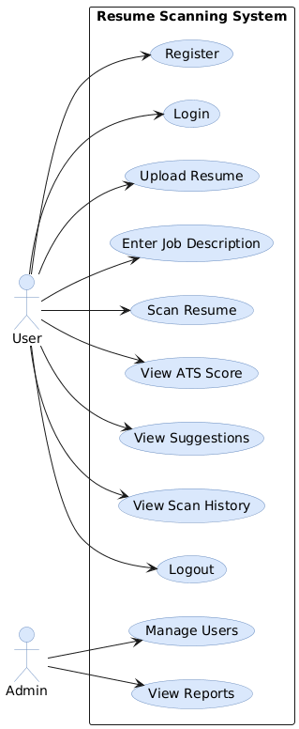
Figure 5.5 illustrates the Use Case Diagram.

5.6 Sequence Diagram

The user first logs into the application through the frontend. The backend authenticates the user using MongoDB. After successful login, the user uploads a resume, which is parsed and analyzed by the ATS Engine. The generated ATS report is stored in MongoDB and displayed to the user.
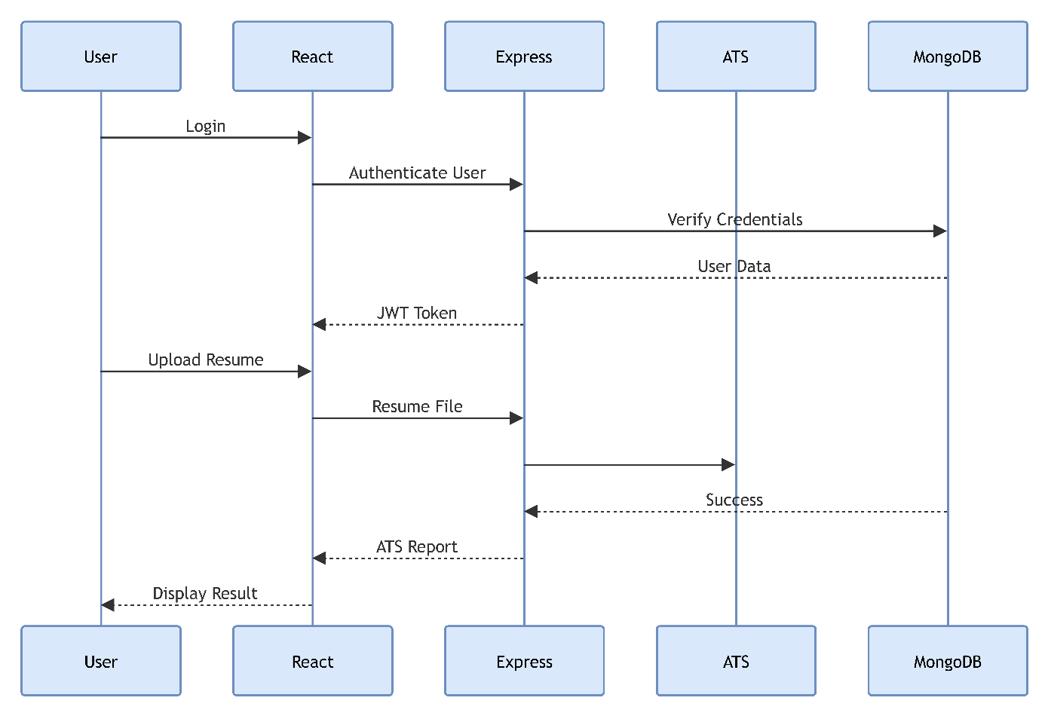
Figure 5.6 represents the Sequence Diagram.

5.7 Activity Diagram
The activity begins when the user logs into the application. After successful authentication, the user uploads a resume and enters the Job Description. The system parses the resume, performs keyword matching, calculates the ATS score, generates recommendations, and finally displays the report to the user.
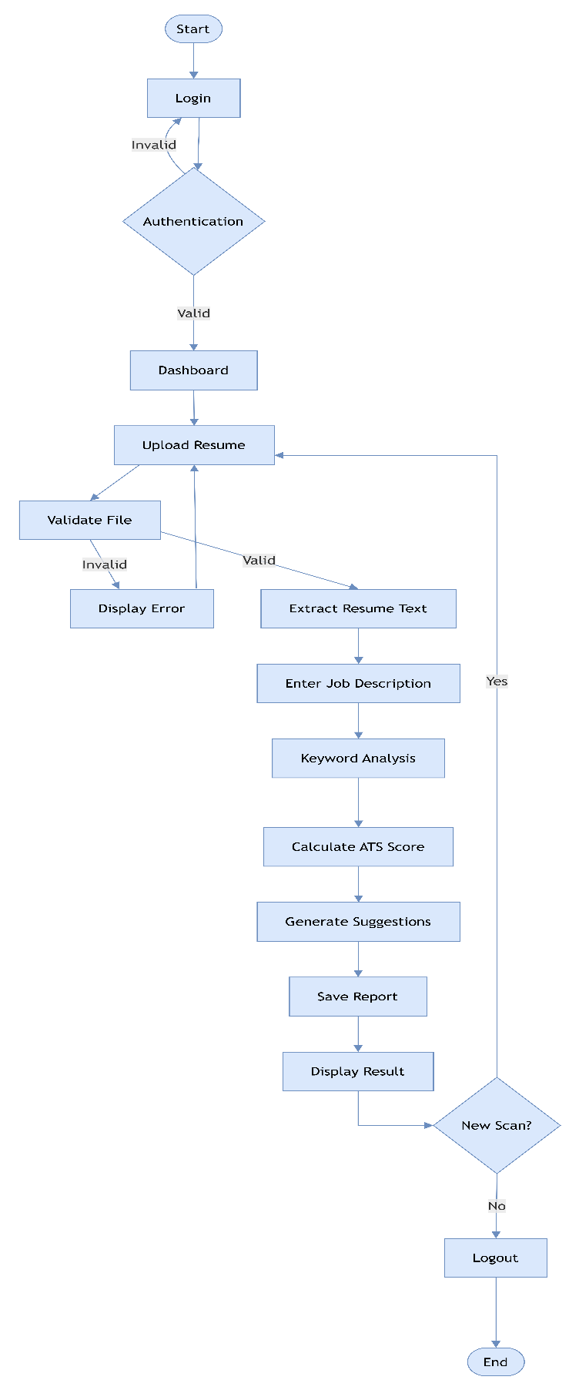
Figure 5.7 shows the Activity Diagram of the Resume Scanning System.

5.8 State Diagram

The system changes its state from Logged Out to Logged In after successful authentication. Once the resume is uploaded, the system moves through parsing, keyword comparison, ATS score generation, and report display before returning to the Logged Out state.

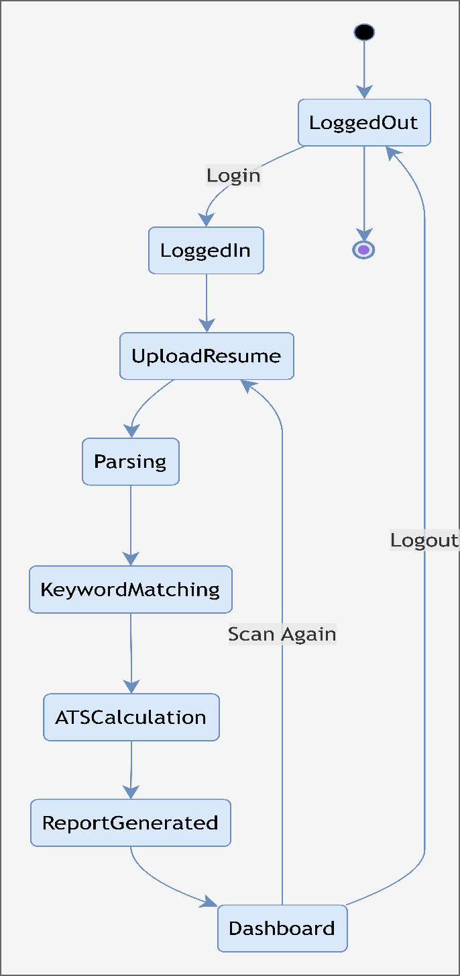

Figure 5.8 illustrates the State Diagram.
5.9 Database Design

MongoDB is used as the database management system for storing user information, uploaded resumes, ATS reports, job descriptions, and scan history. The database follows a document-oriented structure, which provides flexibility, scalability, and high performance.

Users Collection
Field | Data Type | Description
_id | ObjectId | Primary Key
email | String | Required, Unique, Trim, Lowercase
password | String | Required
role | String | Enum: ['user', 'admin'], Default: 'user'
createdAtDateDefault: Date.nowTimestamp of when the account was created. | createdAtDateDefault: Date.nowTimestamp of when the account was created. | createdAtDateDefault: Date.nowTimestamp of when the account was created.

Scans (ATS_Reports_DB)
Field | Data Type | Description
_id | ObjectId | Unique identifier auto-generated by MongoDB.
userId | ObjectId | Links the scan report to the user who created it.
resumeFileName | String | The original name of the uploaded resume file.
resumeText | String | The raw parsed text extracted from the resume.
jobDescriptionText | String | The raw text of the job description provided.
matchScore | Date | The calculated ATS compatibility score (e.g., 0-100).
matchingKeywords | Array of Strings | Keywords found in both the resume and job description.
missingKeywords | Array of Strings | Important keywords missing from the resume.
suggestions | Array of Strings | Actionable feedback to improve the resume.
createdAt | Date | Timestamp of when the ATS scan was performed.

5.10 Entity Relationship Diagram

The Entity Relationship (ER) Diagram illustrates the relationships between Users, Resumes, Job Descriptions, ATS Reports, and Scan History within the Resume Scanning System.
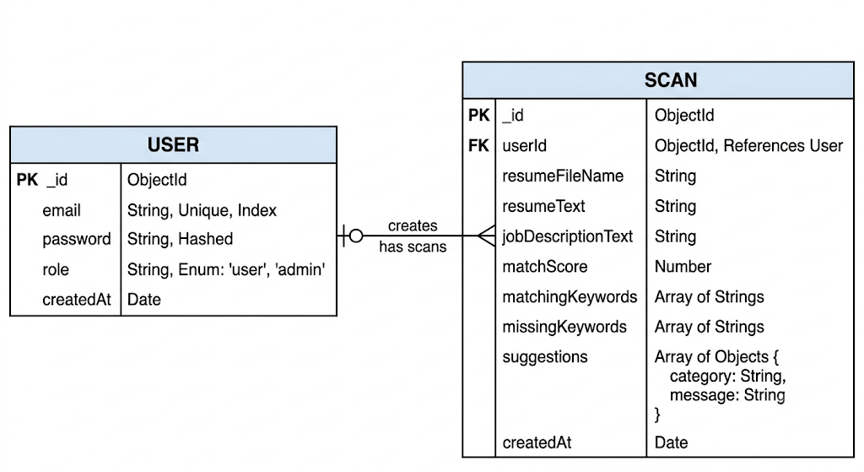
Figure 5.9 represents the Entity Relationship Diagram.

5.11 Menu Design

The Resume Scanning System provides a simple and user-friendly menu structure that enables users to navigate through different modules efficiently. The menu is designed to reduce complexity while improving accessibility.

Main Menu
- Home
- Dashboard
- Upload Resume
- ATS Scanner
- Scan History
- Logout

Administrator Menu
- Admin Dashboard
- Manage Users
- Resume Reports
- Analytics
- Logout

5.12 Screen Design

The user interface is developed using React.js and Tailwind CSS. Every screen is responsive and designed to provide a clean user experience across desktop and mobile devices.

Login Screen
The Login Screen allows registered users to securely log into the system using their email address and password.

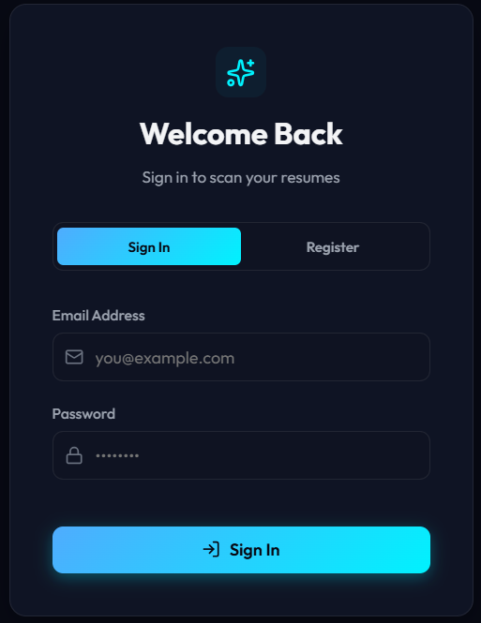

Registration Screen
New users can create an account by entering their personal details and creating login credentials.

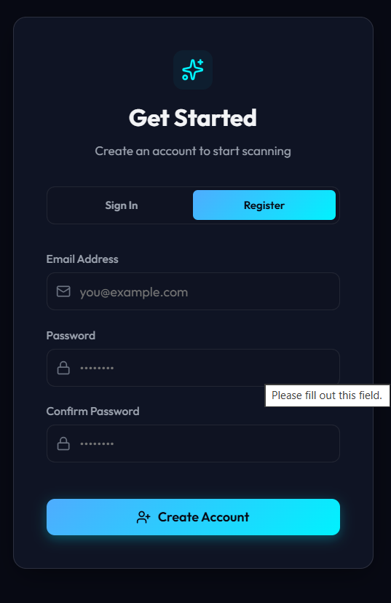

Dashboard
The Dashboard displays ATS scores, recently uploaded resumes, scan history, quick statistics, and shortcuts to frequently used features.

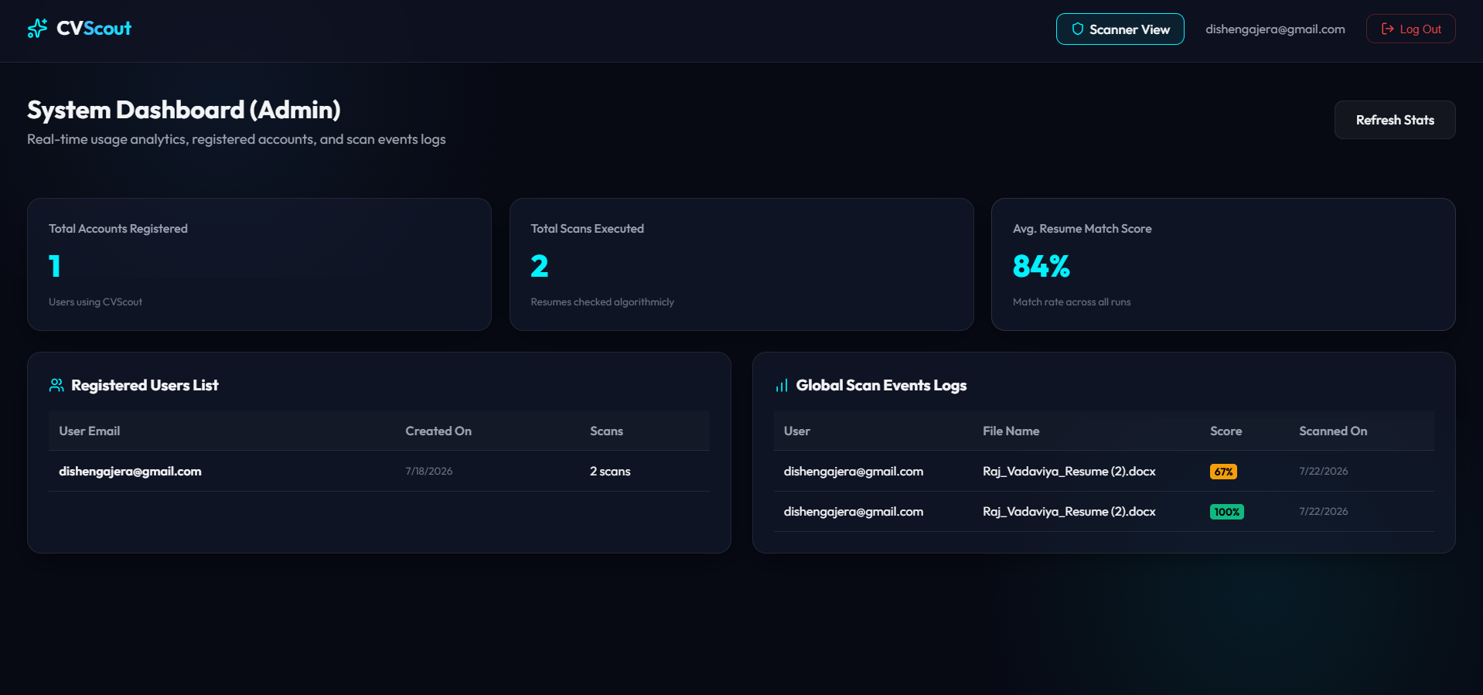

Upload Resume Screen
This screen allows users to upload PDF or DOCX resumes and submit a Job Description for ATS analysis.

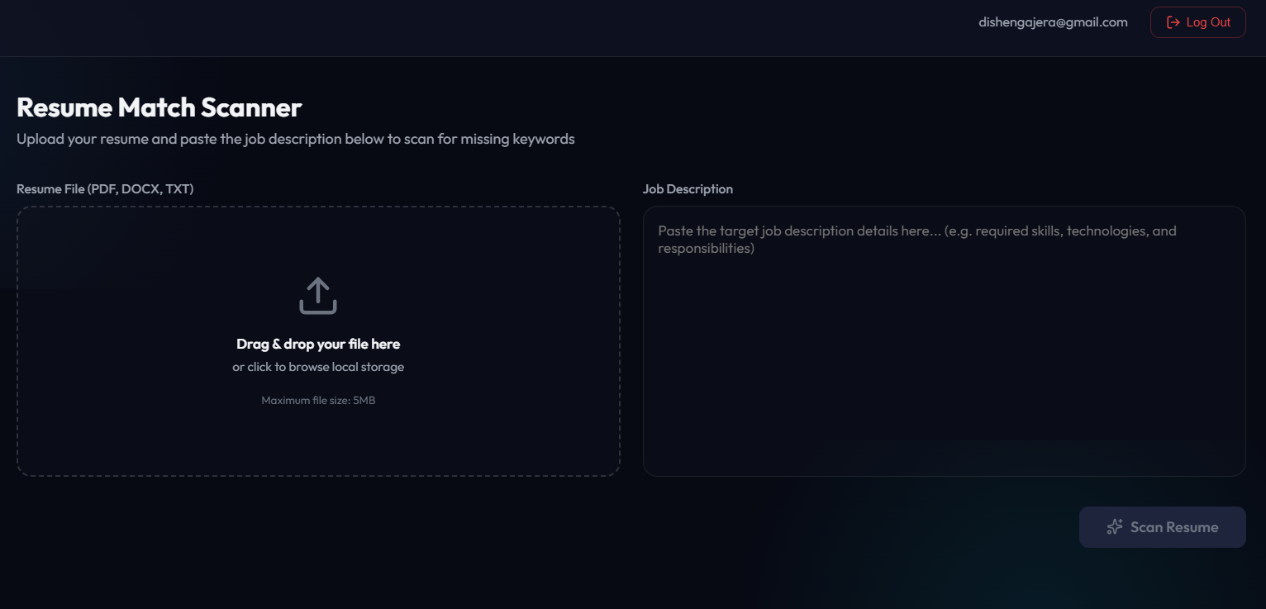

ATS Result Screen
After scanning, the application displays the ATS Score, matched keywords, missing skills, improvement suggestions, and resume summary.

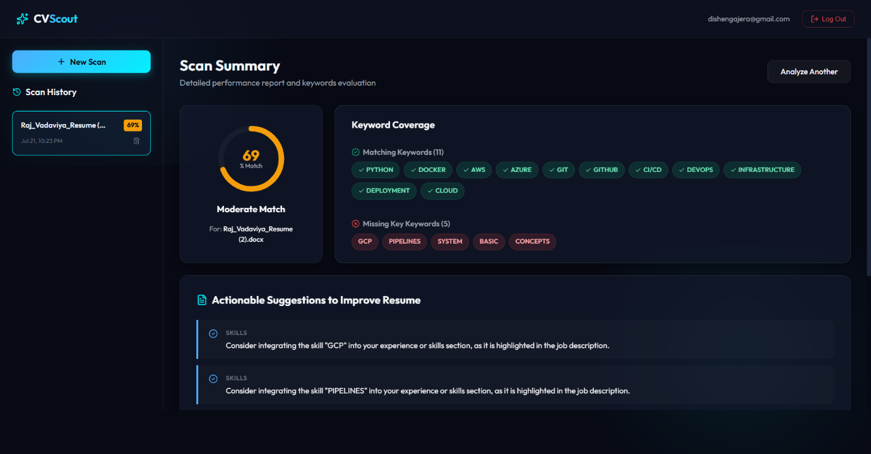

Scan History Screen
The Scan History screen maintains all previous resume analyses along with timestamps and ATS scores.

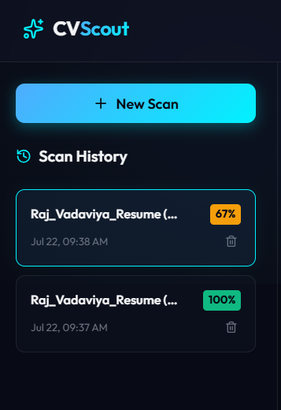
5.13 Code Module

The following Node.js controller demonstrates the ATS Score calculation process used in the Resume Scanning System.
exports.calculateATS = async (req, res) => {
try {
const resumeText = req.body.resumeText;
const jobDescription = req.body.jobDescription;
const resumeWords = resumeText.toLowerCase().split(/\s+/);
const jdWords = jobDescription.toLowerCase().split(/\s+/);
const matched = jdWords.filter(word =>
resumeWords.includes(word)
);
const score = (
matched.length / jdWords.length
) * 100;
res.status(200).json({
atsScore: score.toFixed(2),
matchedKeywords: matched.length,
totalKeywords: jdWords.length
});
}
catch(error){
res.status(500).json({
message:"Unable to calculate ATS Score"
});
}
};

Module Description
The ATS Score module receives the extracted resume text and Job Description from the frontend. It compares the keywords, calculates the compatibility percentage, and returns the ATS score along with matched keywords and recommendations. The generated report is stored in MongoDB and displayed on the user's dashboard for future reference.

Test Cases

Module (a): Login & Authentication Process
Test Case ID | Description | Test Steps | Input Data | Expected Result | Actual Result | Pass/Fail | Comments
TC001 | Valid User Login | 1. Open app URL  2. Select 'Sign In'  3. Enter email  4. Enter password  5. Click 'Sign In' | Email: dishengajera@gmail.com  Password: user@123456 | Redirect to Dashboard, store JWT. | Redirected to Dashboard with active session. | Pass | User successfully logs in.
TC002 | Invalid Password Login | 1. Open app URL  2. Select 'Sign In'  3. Enter email  4. Enter wrong password  5. Click 'Sign In' | Email: dishengajera@gmail.com  Password: wrongpass | Display error: 'Invalid credentials...' | Displayed error alert. | Pass | Password mismatch handled.
TC003 | Unregistered Email Login | 1. Open app URL  2. Enter non-existent email & password  3. Click 'Sign In' | Email: notfound@gmail.com  Password: password123456 | Display error: 'Invalid credentials...' | Displayed error message. | Pass | System prevents login.
TC004 | Blank Fields Login | 1. Open app URL  2. Leave fields blank  3. Click 'Sign In' | Email: (blank)  Password: (blank) | Display error: 'Please fill in all fields.' | Validation blocks submission. | Pass | Mandatory input check works.
TC005 | Valid Admin Login | 1. Open app URL  2. Enter admin email & password  3. Click 'Sign In' | Email: admin@gmail.com  Password: admin@123456 | Log in as Admin role, display Admin Panel. | Logged in successfully. | Pass | System authenticates admin.
TC006 | Short Password Validation | 1. Open app URL  2. Enter email & short password  3. Click 'Sign In' | Email: admin@gmail.com  Password: 12345 | Display error: 'Password must be at least 6 characters'. | Displayed error banner. | Pass | Client-side validation active.

Module (b): User Registration Process
Test Case ID | Description | Test Steps | Input Data | Expected Result | Actual Result | Pass/Fail | Comments
TC007 | Valid User Registration | 1. Click 'Register'  2. Enter valid email, password, confirm password  3. Click 'Create' | Email: newuser@example.com  Password: secret123 | Account created, redirected to Dashboard. | Account created & redirected. | Pass | Pipeline working.
TC008 | Password Mismatch | 1. Click 'Register'  2. Enter mismatched passwords  3. Click 'Create' | Password: pass123  Confirm: pass456 | Display error: 'Passwords do not match.' | Displayed error message. | Pass | Confirmation check works.
TC009 | Duplicate Email Registration | 1. Click 'Register'  2. Enter registered email  3. Click 'Create' | Email: already@example.com | Display error: 'User already exists'. | Displayed error banner. | Pass | Unique email enforced.
TC010 | Restricted Admin Email | 1. Click 'Register'  2. Enter admin@gmail.com  3. Click 'Create' | Email: admin@gmail.com | Display error: 'Registration not allowed'. | Displayed restriction notice. | Pass | Reserved account protected.
TC011 | Short Password Registration | 1. Click 'Register'  2. Enter 4-char password  3. Click 'Create' | Password: 1234 | Display error: 'Password must be at least 6 characters'. | Validation blocked submission. | Pass | Policy verified.

Module (c): Resume File Upload & Parsing Process
Test Case ID | Description | Test Steps | Input Data | Expected Result | Actual Result | Pass/Fail | Comments
TC012 | Valid PDF Resume Upload | 1. Select PDF < 5MB  2. Paste JD  3. Click 'Scan' | File: resume.pdf (1.2MB)  JD: 'React developer...' | File parsed, match summary rendered. | Resume parsed successfully. | Pass | PDF parser working.
TC013 | Valid DOCX Resume Upload | 1. Upload DOCX < 5MB  2. Paste JD  3. Click 'Scan' | File: cv.docx (500KB) | Text extracted, analysis displayed. | DOCX text extracted. | Pass | DOCX parser working.
TC014 | Unsupported File Format | 1. Select image/exe file | File: profile.png | Display error: 'Invalid file format.' | Error message displayed. | Pass | Whitelist enforced.
TC015 | File Oversize Validation | 1. Select PDF > 5MB | File: large.pdf (8.5MB) | Display error: 'File size too large.' | Upload blocked. | Pass | Boundary limit working.
TC016 | Unparseable PDF File | 1. Upload image-only PDF  2. Click 'Scan' | File: scanned.pdf | Display error: 'Could not extract text.' | API returned 400. | Pass | Extraction guard active.

Module (d): Resume Search & Analysis Engine
Test Case ID | Description | Test Steps | Input Data | Expected Result | Actual Result | Pass/Fail | Comments
TC017 | High Skill Match | 1. Upload resume with React, Node  2. Paste matching JD | Resume: React, Node  JD: Requires React, Node | Match Score = 100%. | Score 100% displayed. | Pass | Accurate calculation.
TC018 | Partial Match Score | 1. Upload resume with JS  2. Paste JD with JS, React, Docker | Resume: JS  JD: JS, React, Docker | Match Score = 20%, lists missing skills. | Score 20% with suggestions. | Pass | Dictionary calculated.
TC019 | Missing Contact Info | 1. Upload resume missing email  2. Click 'Scan' | Resume: No email/phone | Suggest adding contact info. | Suggestions block displayed. | Pass | Regex checking verified.
TC020 | Missing Section Heading | 1. Upload resume without Education  2. Click 'Scan' | Resume: No Education header | Suggest adding Education section. | Header suggestion displayed. | Pass | Section verification working.
TC021 | Blank Job Description | 1. Leave JD empty  2. Click 'Scan' | JD: (blank) | Button disabled / Error message. | Constraint fired. | Pass | Mandatory JD enforced.

Module (e): Scan History Management Process
Test Case ID | Description | Test Steps | Input Data | Expected Result | Actual Result | Pass/Fail | Comments
TC022 | Fetch User Scan History | 1. Log in  2. Observe sidebar | User:  dishengajera@gmail.com | Display past scans sorted by date. | Sidebar populates list. | Pass | API returns history.
TC023 | Load Past Scan Summary | 1. Click scan item in history | Click: resume_v1.pdf | Workspace renders full summary. | Report loaded instantly. | Pass | State sync verified.
TC024 | Delete Scan Item | 1. Click trash icon  2. Confirm | Click: delete old_cv.pdf | Item removed, workspace resets. | Scan deleted. | Pass | DELETE route verified.
TC025 | Empty History State | 1. Register new user  2. View sidebar | User: raj@gmail.com | Display graphic: 'No scans found.' | Empty state displayed. | Pass | Fallback handled.

Module (f): Admin Dashboard & Bulk Scanner
Test Case ID | Description | Test Steps | Input Data | Expected Result | Actual Result | Pass/Fail | Comments
TC026 | Admin Dashboard Access | 1. Log in as admin  2. Click 'Admin Panel' | Role: Admin | Admin View loads metrics. | Metrics rendered. | Pass | Routes populated.
TC027 | View Global Scan Log | 1. Click row in Global Logs | Click: user scan event | Display full report & raw text. | Report displayed. | Pass | Inspection view verified.
TC028 | Non-Admin Prevention | 1. Log in as user  2. Request /api/auth/users | Header: User Token | HTTP 403 Forbidden. | HTTP 403 returned. | Pass | Authorization working.
TC029 | Bulk 'Scan All' Execution | 1. Enter JD, Min ATS 50%  2. Click 'Scan All' | JD: React CSS  Min ATS: 50 | Returns ranked list of candidates. | Ranked table rendered. | Pass | Algorithm functional.
TC030 | Scan All Blank JD Input | 1. Leave JD blank  2. Click 'Scan All' | JD: (blank) | Display error: 'Please enter job description'. | Error banner displayed. | Pass | Input validated.

Test Case ID | Test Case Description | Test Steps | Input Data | Expected Result | Actual Result | Pass/Fail | Comments
TC001 | Valid User Login | 1. Open app URL  2. Select "Sign In" tab  3. Enter registered email  4. Enter correct password  5. Click "Sign In" button | Email: john.doe@example.com  Password: user@123 | Redirect to Dashboard, store JWT token in localStorage, display user email in header. | Redirected to Dashboard with active session. | Pass | User successfully logs in.
TC002 | Invalid Password Login | 1. Open app URL  2. Select "Sign In" tab  3. Enter valid email  4. Enter incorrect password  5. Click "Sign In" button | Email: john.doe@example.com  Password: wrongpass | Display error message: "Invalid credentials, please check your password". | Displayed error alert with expected text. | Pass | Password mismatch properly handled.
TC003 | Unregistered Email Login | 1. Open app URL  2. Select "Sign In" tab  3. Enter non-existent email  4. Enter password  5. Click "Sign In" button | Email: notfound@example.com  Password: password123 | Display error message: "Invalid credentials, please check your email". | Displayed error message as expected. | Pass | System prevents non-existent account login.
TC004 | Blank Fields Login | 1. Open app URL  2. Leave Email & Password blank  3. Click "Sign In" button | Email: (blank)  Password: (blank) | Display error message: "Please fill in all fields." | HTML5 / React state validation blocks submission with alert. | Pass | Mandatory input check works.
TC005 | Valid Admin Login | 1. Open app URL  2. Select "Sign In" tab  3. Enter admin email  4. Enter admin password  5. Click "Sign In" button | Email: admin@gmail.com  Password: admin@123 | Log in as Admin role, display "Admin Panel" toggle button in top navbar. | Logged in successfully with Admin privilege. | Pass | System auto-provisions or authenticates admin account.
TC006 | Short Password Validation | 1. Open app URL  2. Enter email  3. Enter password shorter than 6 characters  4. Click "Sign In" button | Email: john.doe@example.com  Password: 12345 | Display error message: "Password must be at least 6 characters long." | Displayed error banner. | Pass | Client-side length validation active.

